Exercises with Repetition

Create a folder called repetition_LastNameF and save the following exercises to it. When all the exercises have been completed, copy the folder into the drop off.

1. Write a program that announces at each repetition of a loop the number of times it has executed the loop. Have it stop at each execution with the message.
Type ‘more’ to continue
Bulletproof it so that it doesn’t matter whether ‘more’ is entered in upper or lower case, or whether they misspell the word after the first letter.
A sample execution would be:

Loop execution number 1
Type ‘More’ to continue More

Loop execution number 2
Type ‘More’ to continue More

Loop execution number 3
Type ‘More’ to continue Stop

Save as repetitionEx1.py

2. Write a program to output a table that converts miles to kilometers. Do it for 1 to 10 miles and display the kilometer conversion with two decimal points. Your table should be indented by about dozen spaces from the left margin. The headings should be centred over the numbers. There should be a dotted line under the heading. The column of numbers should be right justified. It should look like the following:
Miles Kilometers
----- ----------
1 1.61
2 3.22
3 4.83
4 6.44
5 8.05
6 9.66
7 11.27
8 12.87
9 14.48
10 16.09
Save as repetitionEx2.py

3. A series of marks is to be entered and averaged. Before you enter the series, you are to have the program ask the user how many marks there are. After the last mark is entered, show the average of the inputted marks, rounded to 1 decimal point. Test your program to ensure that it works for series of different lengths, say four marks or six marks. Verify average that you get with your program with a calculator. Your output should look like:

How many marks will you be entering? 4
Enter a mark #1. 57
Enter a mark #2. 99
Enter a mark #3. 72
Enter a mark #4. 37
Your average mark of the 4 is 63.3 percent

Save as repetitionEx4.py

4. Write a program to do a backwards countdown to a blastoff of a rocket. Your first line of output will be the statement “This is the final countdown”. Your second line will be the countdown from 10 to 1, with five spaces between each number. Your last line will be “Blastoff”. Your output will look like:

This is the final countdown
10 9 8 7 6 5 4 3 2 1
Blastoff!
Save as repetitionEx5.py

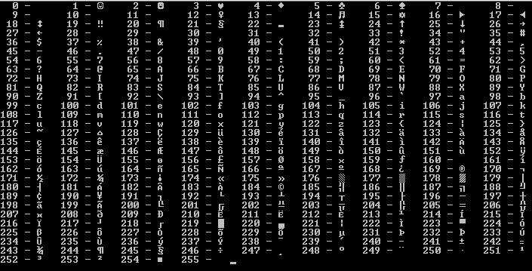
5. The function for printing the ASCII character for a number is chr(Number). For example: chr(76) is ’L’ and chr(243) is ‘¾’. Similarly, there is an ord function to do the same in reverse. For example ord(‘L’) is 76 and ord(‘%’) is 37. Write a program that will display all the ASCII characters from 0 to 255 on one screen. Your output should look something like the following:

